

**RE01FGC**

May 2 2025

|  |
| --- |
| **16 Position Gray Code Rotary Encoder** |

**FEATURES**

* **16 Rotary Positions with Discrete Mechanical Detents**
* **Accepts 1.65 V up to 5 V Logic Levels**
* **Breadboard Compatible**
* **Robust and Simple Output**
* **Quick Computation of Gray Code**
* **Integrated Decoupling Capacitor**
* **Compact 15x14 mm Size**
* **Cheap Manufacturing**
* **Manually Manufacturable**

**DESCRIPTION**

The RE01FGC is a compact, 16-position Gray Code rotary encoder module. It converts a 4‑bit binary value generated by an onboard rotary switch into a 4-bit Gray Code output using three integrated XOR gates. The resulting output provides robust and clean signals, ideal for breadboard prototyping.

The module is designed to operate at 1.65 V and up to 5V logic levels, with clean signal transitions and convenient breadboard pin spacing, making it ideal for rapid prototyping and educational purposes. Each position on the rotary switch corresponds to a unique value in Gray Code value.

|  |  |
| --- | --- |
|  |  |

See device information for dimensions

**Device Overview**

* Texas Instruments SN74LVC1G86DCKR XOR Gate

<https://www.lcsc.com/datasheet/lcsc_datasheet_2410121946_Texas-Instruments-SN74LVC1G86DCKR_C52350.pdf>

* ECE ERD216RSZ 16 Position Rotary Encoder

<https://www.lcsc.com/datasheet/lcsc_datasheet_2410241443_ECE-ERD216RSZ_C40425407.pdf>

When choosing capacitors and resistors, ensure power ratings are adequate for their functions on the device. The 5 V limit is due to the XOR Gates.

**Logic Diagrams**

Truth Table:

|  |  |  |  |  |  |  |  |
| --- | --- | --- | --- | --- | --- | --- | --- |
| **Bin3** | **Bin2** | **Bin1** | **Bin0** | **GC3** | **GC2** | **GC1** | **GC0** |
| 0 | 0 | 0 | 0 | 0 | 0 | 0 | 0 |
| 0 | 0 | 0 | 1 | 0 | 0 | 0 | 1 |
| 0 | 0 | 1 | 0 | 0 | 0 | 1 | 1 |
| 0 | 0 | 1 | 1 | 0 | 0 | 1 | 0 |
| 0 | 1 | 0 | 0 | 0 | 1 | 1 | 0 |
| 0 | 1 | 0 | 1 | 0 | 1 | 1 | 1 |
| 0 | 1 | 1 | 0 | 0 | 1 | 0 | 1 |
| 0 | 1 | 1 | 1 | 0 | 1 | 0 | 0 |
| 1 | 0 | 0 | 0 | 1 | 1 | 0 | 0 |
| 1 | 0 | 0 | 1 | 1 | 1 | 0 | 1 |
| 1 | 0 | 1 | 0 | 1 | 1 | 1 | 1 |
| 1 | 0 | 1 | 1 | 1 | 1 | 1 | 0 |
| 1 | 1 | 0 | 0 | 1 | 0 | 1 | 0 |
| 1 | 1 | 0 | 1 | 1 | 0 | 1 | 1 |
| 1 | 1 | 1 | 0 | 1 | 0 | 0 | 1 |
| 1 | 1 | 1 | 1 | 1 | 0 | 0 | 0 |

Boolean Expressions:

Logic Diagram:

**Bin3** **GC3**

**GC2**

**Bin2**

**GC1**

**Bin1**

**GC0**

**Bin0**

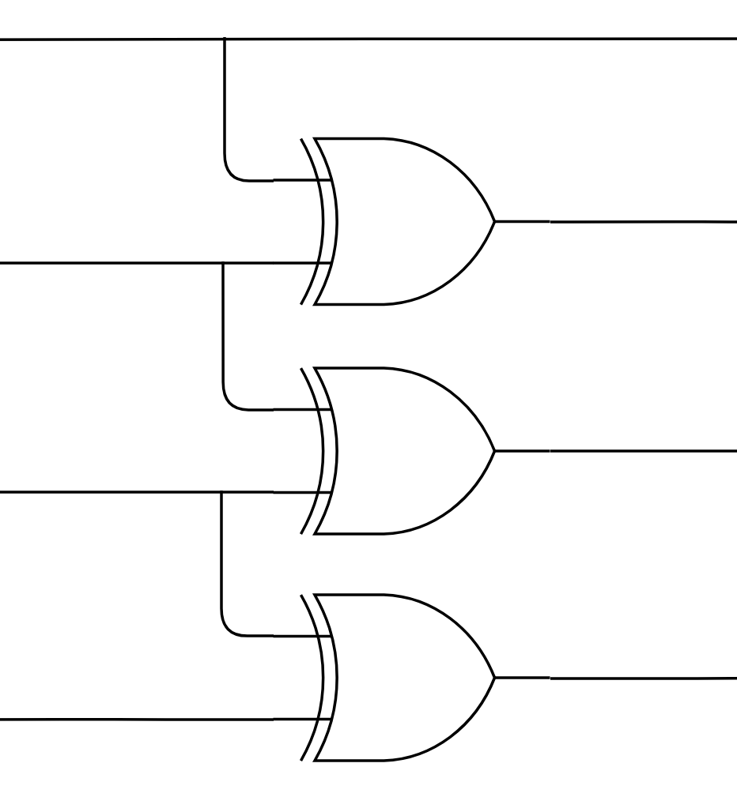

**Electrical Characteristics**

|  |  |  |  |  |
| --- | --- | --- | --- | --- |
|  | **Min** | **Typ.** | **Max** | **Unit** |
| Vcc Input & Logic Voltage | 1.65 | - | 5 | V |
| Vo Output Voltage | 0 | - | Vcc | V |
| Iout Output Current | 0 | - | 50 | mA |
| tpd Switching time (5V) | 1 | - | 4 | ns |
| Δt/ΔV Input Rise/Fall Time (5V) |  | 5 |  | ns/V |
| TA Operating Temperate | -4 | 25 | 125 | °C |

**Schematics & Technical Diagrams**



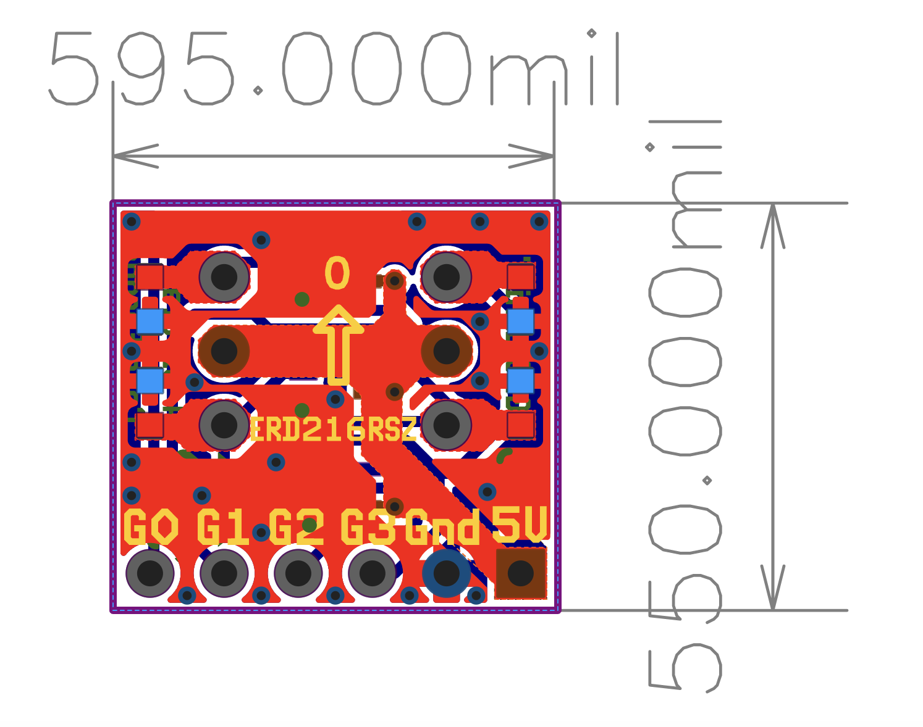

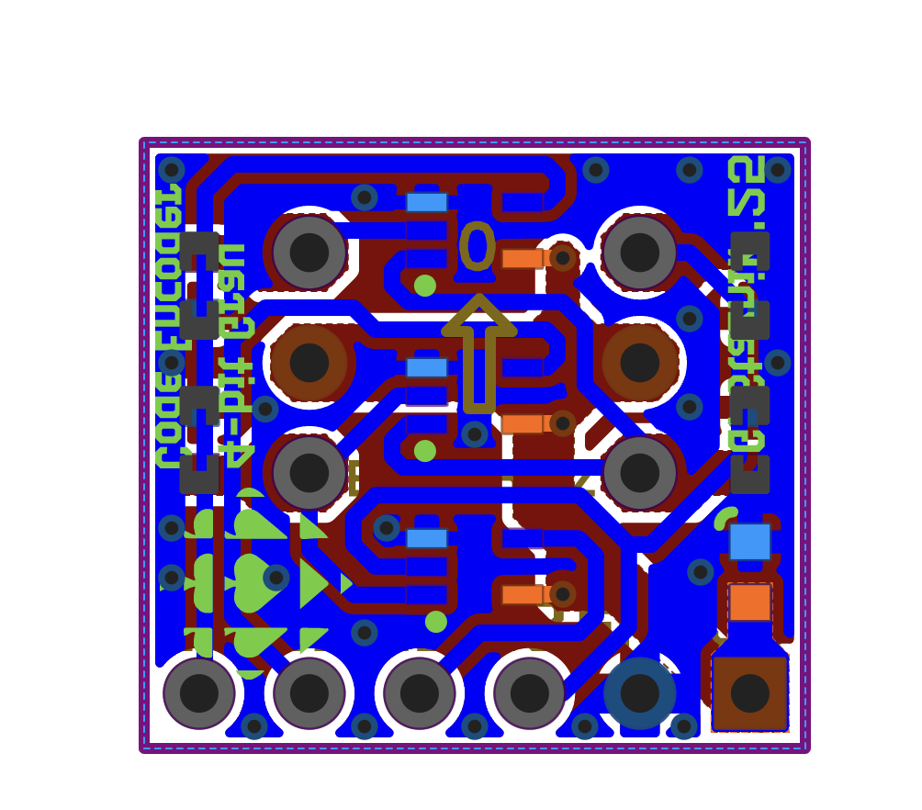

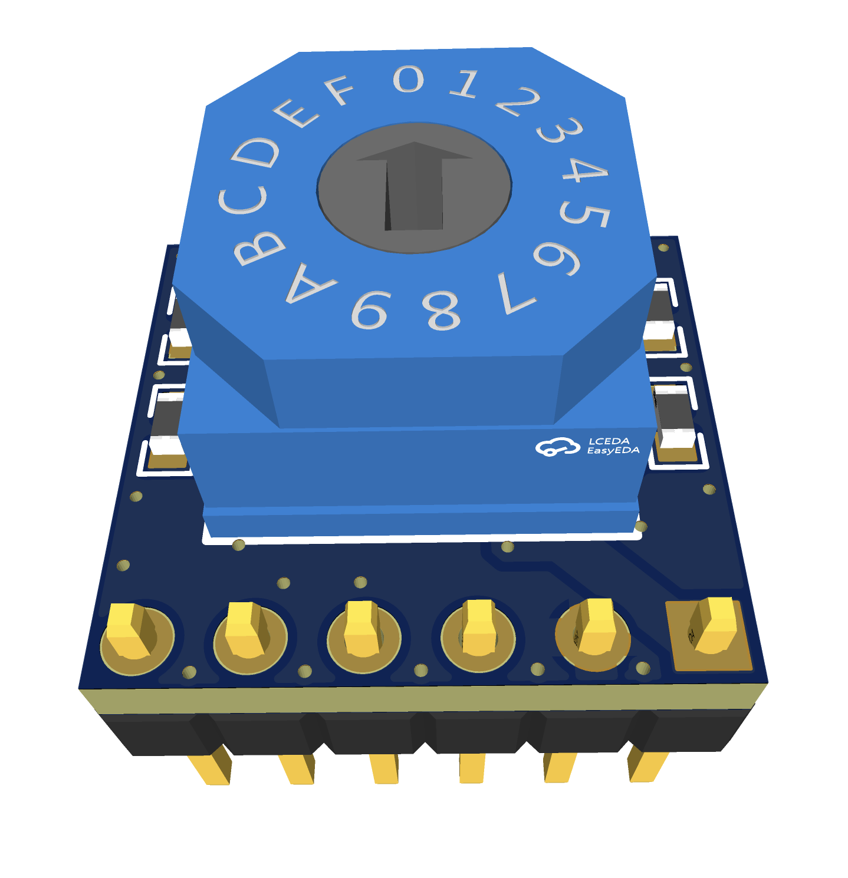

Note the silkscreen is different on the final product

**Ordering Information**

The RE01FGC was designed with the express purpose of ease and low cost of manufacture. All parts were ensured to be available on LCSC.

Below are the specifications that are required to produce the RE01FGC PCB:

|  |  |  |
| --- | --- | --- |
|  | **Spec.** | **Unit** |
| Minimum Trace clearance | 0.6 | mm |
| Minimum Trace Width | 6 | mil |
| Minimum Via Drill Size | 0.3 | mm |
| Via Hole to Hole Spacing | 0.6 | mm |
| Trace/Via to Copper Pour Clearance | 0.6 | mm |
| Minimum Character Width | 6 | mil |

Here are the specifications when producing or ordering the PCB:

|  |  |  |
| --- | --- | --- |
|  | **Spec.** | **Unit** |
| PCB Layers | 2 |  |
| Board Material | FR-4 |  |
| Board Thickness* | 0.6 | mm |
| Board Dimensions | 595x550 | mil |
| Colour | -- |  |
| Surface Finish** | -- |  |
| Outer Copper Weight | 1 | oz |
| Via Coverings | -- |  |

*Other thicknesses are acceptable, though it is recommended to keep the board thin for better grounding with the ground pours.

**Surface finish can be determined by the user, however, ENIG is recommended for applications requiring stocking the un-manufactured PCB for long periods of time. Tough HASL is acceptable in most cases.

When manufacturing the PCB, ensure that all components are correctly placed, and the direction of the XOR ICs are correct. Also ensure that the chosen parts match the specifications.

**Important Notice**

Staznik Systems provides this open-source hardware design “as-is” and makes no warranties regarding its reliability, functionality, or fitness for a particular purpose. Users are responsible for verifying the suitability of this design for their specific applications and for incorporating appropriate safety and performance safeguards.

This design is released under an open-source license for educational, hobbyist, and experimental use. While reasonable care has been taken to ensure the accuracy and utility of the design, Staznik Systems assumes no liability for any damage or loss resulting from the use of this design or any derivative work.

Modifications, redistribution, and use in commercial or non-commercial applications are permitted, provided that proper credit is given and any derivative works are clearly marked as such. The name “Staznik Systems” and any associated logos or marks may not be used to promote derivative works without prior written permission.

Staznik Systems does not authorize the use of this design in life-critical or safety-critical systems without an explicit and separate agreement.

© Staznik Systems. This project is open-source. All contributions and derivatives must comply with the accompanying GNU license.